**R Code for Examples in the book**

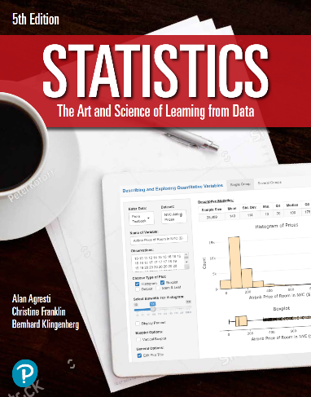

***“Statistics: The Art and Science of Learning from Data”***

**by Agresti, Franklin and Klingenberg, 5th edition**

**Chapter 11**

**Example 4: Happiness and Income – Chi-Squared Distribution**

## Reading in data:

mytable <- as.table(matrix(c(29, 178, 135, 83, 494, 277, 104, 314, 119),   
 nrow = 3, byrow = TRUE,   
 dimnames = list(income =   
 c('above', 'average', 'below'),  
 happy =   
 c('not', 'pretty', 'very'))))

## To perform a chi-squared test for independence

mytest <- chisq.test(mytable)

## To view the p-value

mytest$p.value

## [1] 5.154502e-11